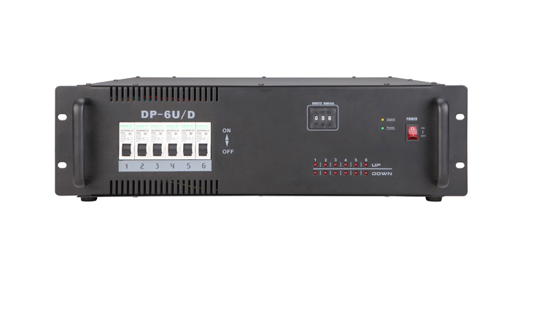

CEE DP-6U/D

Function and performance:
The RS-485 signal control
32 channel signal output
Every channel has a separate control buttons of rise and fall.
Eight function in programming
210V-240V voltage input,50Hz.
Standard 3U machine cabinet installation.

