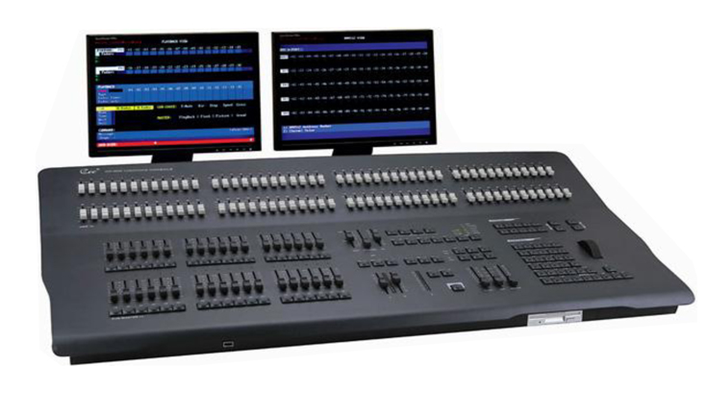

CEE CP-600

Technical parameter：

CEE CP-600 “WANGLONG” English Computer Lighting Console
Function and performance
●maximum 1024 channels,1024 DMX512 channels, 96 faders, 36 sub-masters .
●can patch one or two TFT monitor, the Chinese and English user interface.
●96 fades ,36 sub-masters (9 pages), 4 effect starters.
●2000 scenes, 99 effects (99 steps), 1000 groups, 99macros
● USB flash memory function.
●military technology, and component adopt ,Dual power unit and dual machine backup function .Backup machine can pre-store more than 100 scenes to secure operation.
●with Chinese-English help system. May retrieve and read the lighting console information at ease, facilitates the user.
●can upgrade and promote the TCP/IP network and optical outputs, and with light-controlled Ethernet.
Technical Parameter
● working voltage: AC220V±10%,50Hz±2%
●output signal: DMX-512(1990).
●may select purchase the TCP/IP network signal output, and optical fibre outputs
●ambient temperature: - 20℃±45℃
● relative humidity: 20%-90%
●working conditions: Ventilates good, not massive mist and dust
Order information
Model | Description | Size | Weight
CP-600 | 100-2048ch,96faders 36submasters（9 pages）

