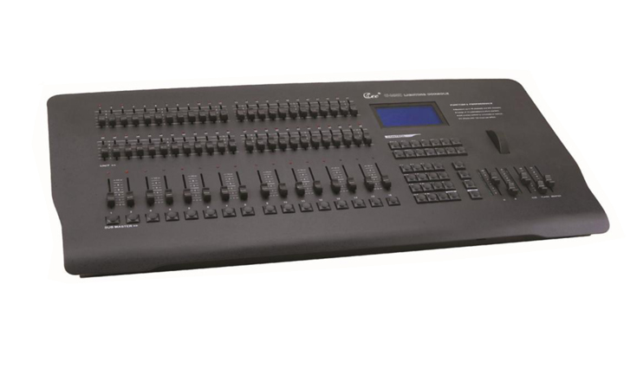
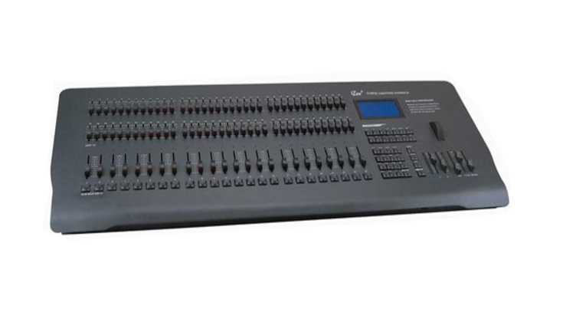
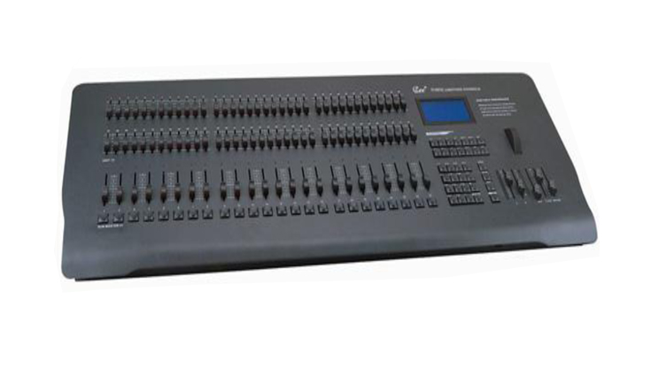

CEE CP-24/48D、CP-36/72D、CP-120D

Technical parameter：

CP-24/48D、CP-36/72D、CP-120D“ CEE ” Computer Console
Function and performance
●The first adoption of the multi-color background lighting keyboard for lighting console, easy for virtually control
●Maximum up to 120 channels and 512 dimmers
●72 faders maximum up to 96 control faders or A/B cue
●3 pages of 24 sub-masters ,4 effect starters
●200 scenes control by automatic or manual
●9 effect with 120 steps per effect It can set up the operation direction and modify speed. Extended width LCD, keyboard type instruction.
●Wheel for figuration ,easy to operate ,it offers random access memory and IC card flash memory function
●Standard DMX-512 output

Technical Parameter:
●Working voltage: AC220V±10% 50HZ±2%
●Output signal:DMX-512(1990)
●Environmental temperature : -20℃～+45℃
●Relative hunidity:20%-90%
●Working environment: Ventilating well ,and where there is not a large amount of smoke and dust

Order Information
Model | Description | Dimension (mm) | Weight
CP-24/48D | 48 channels  48faders ,16 sub-masters
CP-36/72D | 72 channels  72faders ,24 sub-masters
CP-120D | 120 channels  72faders ,24 sub-masters

