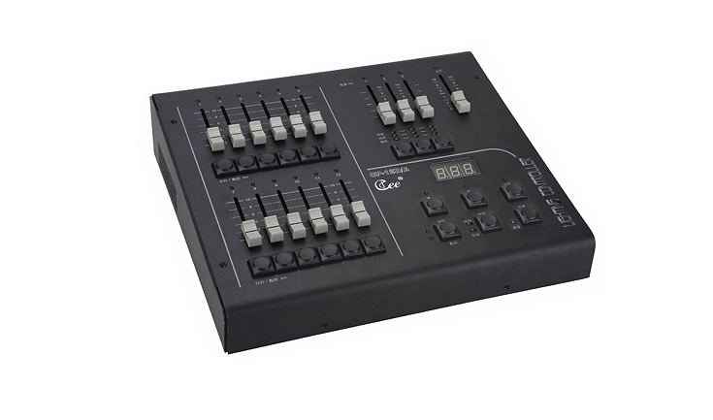
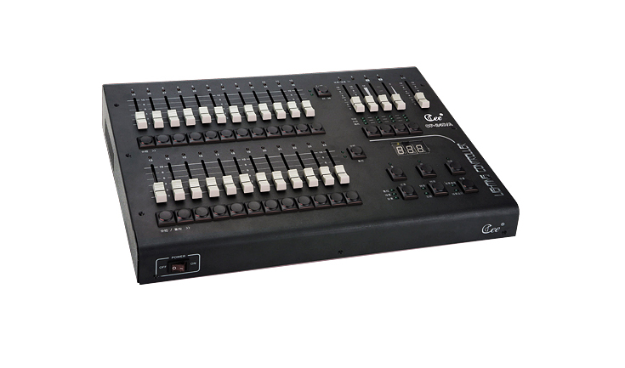
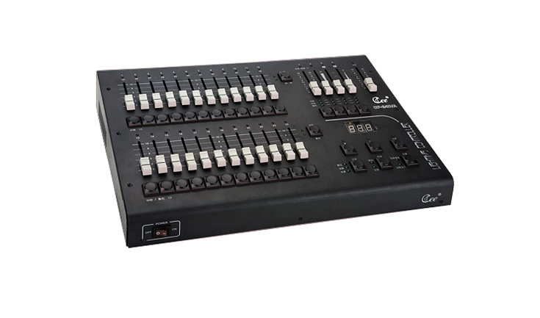

CEE CP-12D/A、CP-24D/A、CP-36D/A

Function and performance:
CP-12D/A:contains 12faders,which can be 12 SUB as well;3 effect starters,12 channels output.
CP-24D/A:contains 24 faders ,which can be 24 SUB as well;4 effect starters(two of them can be as A/B CUE controlled manually);24 channels output.
CP-36D/A:contains 24 faders, which can be 36 SUB as well; 4 effect starters(two of them can be as A/B CUE performed manually);36 channels output.
Scenes can be performed manually, and the console contains ADD/SWOP two flash effects.
DMX address can be changed facility.

Technical parameter:
Voltage :AC220V±10%，50Hz±2%.
Output:DMX-512(1990)(option:0-10V analogy signal output);output channels:12,24,48.
Environmental temperature:-20℃~+45℃.
Relative humidity:20%~90%.
Working environment: Ventilating well, and where there is not a large amount of smoke and dust.

