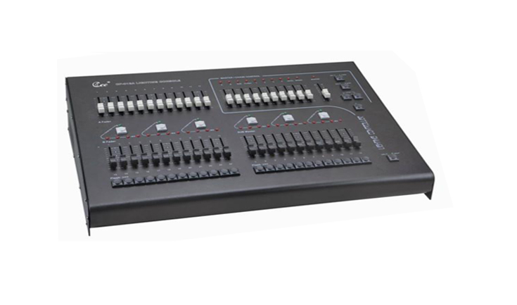
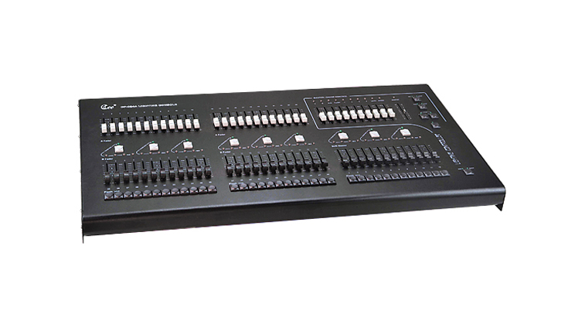

CEE CP-12/24A、CP-24/48A

Function and performance
●Digital/Analogy lighting console series consists of the 12/24 channels or 24/48 channels , being used in medium or small-sized performance terms or mobile recreational groups .
●ADD/SWOP two flash effects ,4 groups Preset programmable control and add A/B cue directly
●A or B cue control ,easy for user to switch scenes
●It offers ground master ,FX master A/B master and flash level
●12 sub-masters ,facilitate the operation
Technical Parameter
●Voltage: AC220V±10%，50Hz±2%
●output:DMX-512（1990）(option:0-10V analogy signal output)
- Output channel:12,24,48
●Environmental temperature : -20℃～+45℃
●Relative hunidity:20%-90%
●Working environment: Ventilating well ,and where there is not a large amount of smoke and dust
Order information
Model | description | Dimension(MM)
CP-12/24A | 24 faders  10submasters,4 channels controllable program
CP-24/48A | 48 faders  10submasters,4 channels controllable program

