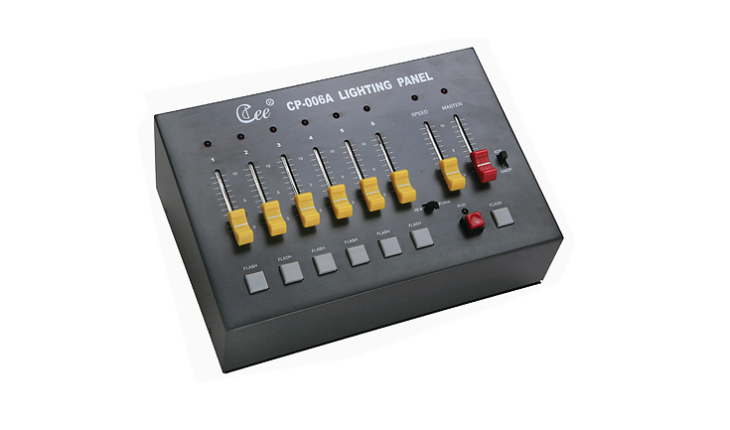
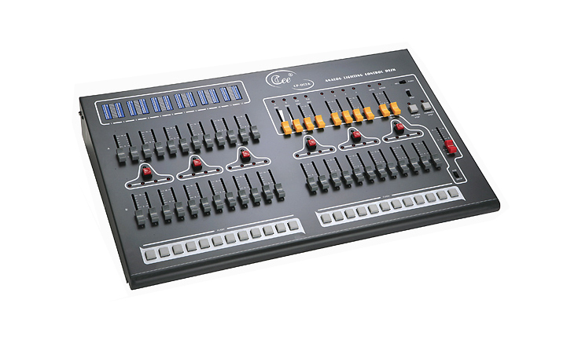

CEE CP-006A、CP-012A

CP-006、CP-012A Analogy Console

Function and performance
●Analogy lighting console series consists of the 6 channels or 12 channels , being used in medium or small-sized performance terms or mobile recreational groups .
●AA/SWOP two flash effects ,4 groups Preset programmable control and add A/B cue directly
●A or B cue control ,easy for user to switch scenes
●It offers ground master ,FX master A/B master and flash level
●It sub-masters，simplified the operation.
Technical parameter：
●Working voltage: AC220V±10%, 50Hz±2%
●0-10V analog signal output
●Output channel :6,12

Order information
Molude | description | Dimension(MM)
CP-006A | 6faders,6 channels controllable program | 260*175*100
CP-012A | 12faders,10submasters,4channels controllable program | 600*370*100

