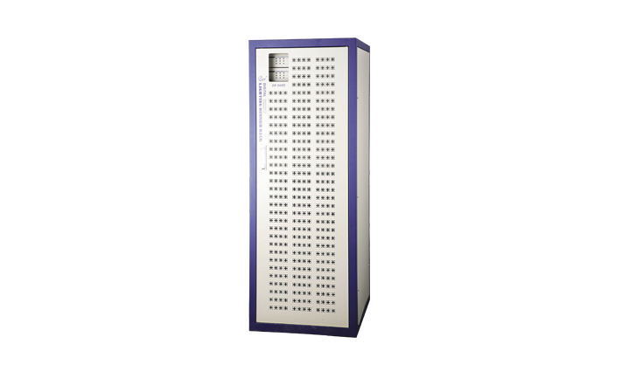
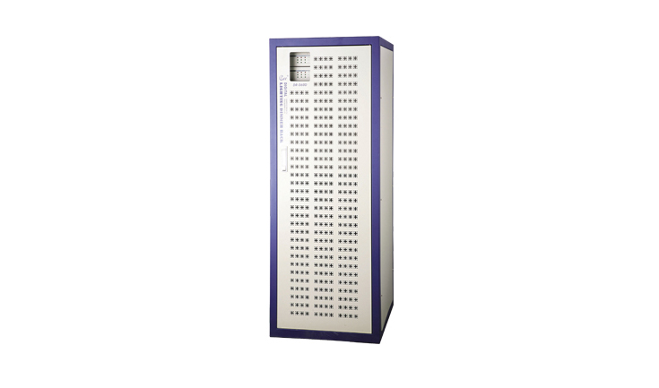
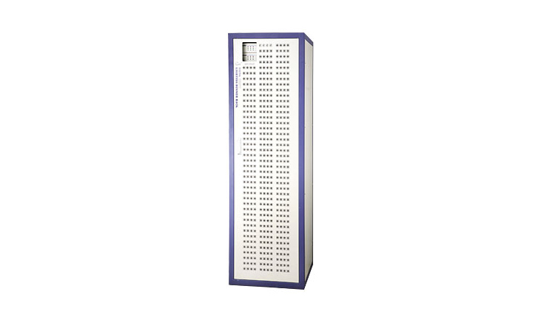
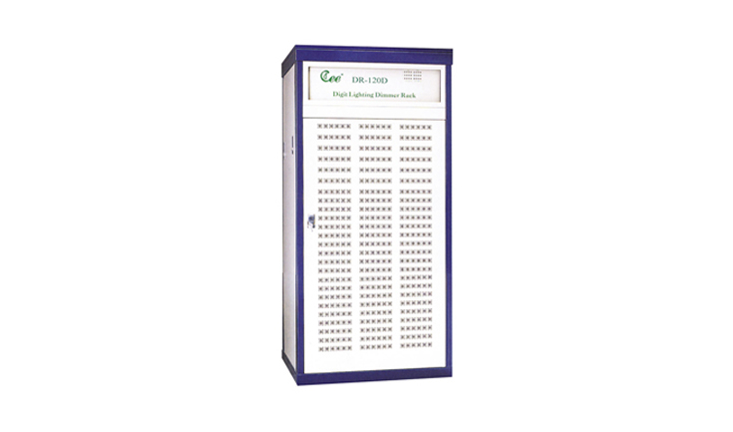

CEE DR-060D、DR-072D、​DR-096D、DR-120D

DR-060D、DR-096D、DR-120D Double Digital Dimmer Rack

Function and performance
● ●Brand-new appearance design with compact structure rational heal dissipation structure ,high efficient dust filter and powerful low noise fan prolong the service life of equipment
● ●Digital duplex intelligent dual decoder designed based on military standard , stave decoder will take the work in 0.11 second automatically if the main decoder breaks down and show the wrong place ,which assure the reliance and stability of the system
● ●High efficient anti-interference magnet ring protect the AV equipment from interference .Defend to strike by lighting and high –voltage , assure the equipment safe ,Scene retain without DMX signal suddenly for preventing blackout.
● ●Dimmer and power match easily .From 60 dimmers to 120 dimmers is available , 3kw or 6kw power.
● ●The whole equipment passed the First Grade Equipment of International Standard. It can allot the signal and voltage equally. Multifarious control signals and lighting control curves for user to choose.
● ● Input and output power supply can be connected from top or bottom.
- 60 or 72 or 96 channel outputs(6kw/channel)*120 channel outputs(3kw/channel)
Technical Parameter:
●Power:3-PH 5-wire/monophase 3-wire 50Hz±1Hz
●Mono-phrase at AC220V±10%（AC）
●Dimmer module :6kw or 3kw
●Control signal:DMX-512(digital) ventilation
●Temperature: -10℃~+35℃ no smoke and dust
●Humidity: 20%~90%， Work bar: 86~106Kpa
Order Information
Model | Description | Dimension(mm)
DR-060D | 60channel(6kw/channel),digit lighting
DR-096D | 96channel(6kw/channel),digit lighting
DR-120D | 120 channel(3kw/channel),digit lighting

