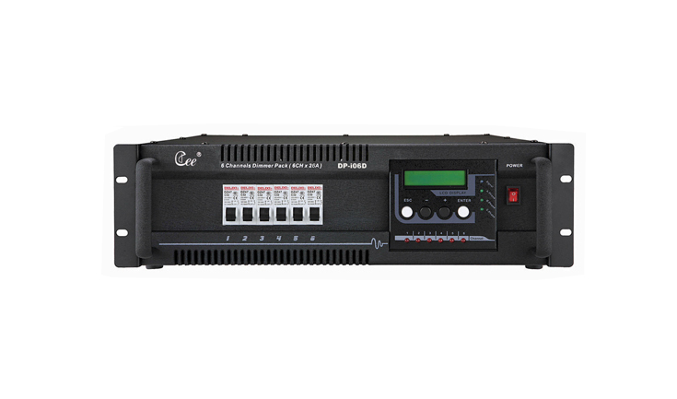
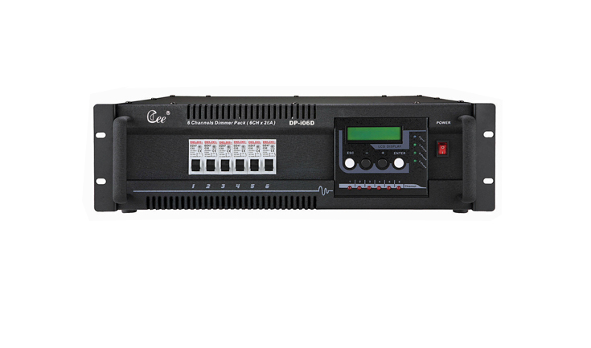

CEE DP-i06D,DP-i12D

DP-i06D、DP-i12D LCD dimmer rack

Function and performance
●LCD monitor
●Triggering accuracy:1024 degree
●Lighting range :0-100%
●The preheating setting function :it is 0%-20% that each channel can be set dependently
●The amplitude of limit setting function :it is 80%-100%that each channel can be set dependently
●The working mode of channel setting function :each channel can set forever-zero switch mode or lighting mode independently
●Intellectual fan control function : when the temperature in the rack is reached 50℃,it can turns on the fan and dispels the heat automatically
●Intellectual temperature reporting function: when losing DMX signal, it can turn into scene of
●Intellectual self-control function .
●Signal output: 6channel（6KW/channel），12 channel（3KW/channel）

Technical parameter:
●Power input: three phase five line system/mono-phase three line system, mono-phase control voltage 220V±10%AC 50Hz±1Hz
●Controlling signal:DMX-512(1990)
●Environmental temperature : -10℃～+35℃
●Relative hunidity:20%-90%
●Working environment: Ventilating well ,and where there is not a large amount of smoke and dust

Order Information
Model | Description | Size (mm) | weight
DP-i06D | 6ch(6kw/ch),digit lighting | 482*470*145 | 17kg
DP-i12D | 12ch(3kw/ch),digit lighting | 482*470*190 | 18.5kg

