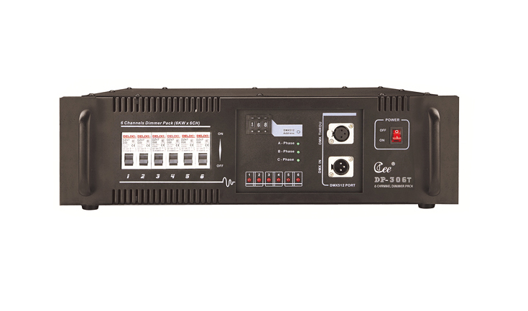
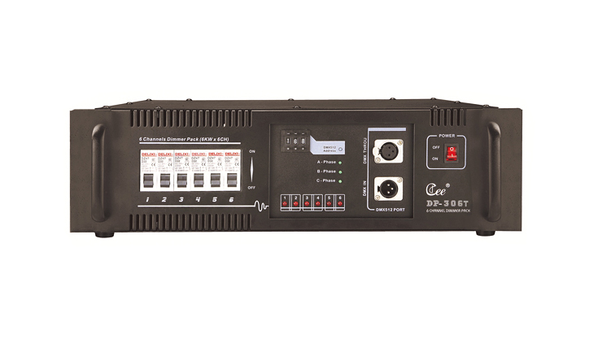

CEE DP-106D,DP-306T

DP-106D Uniphase Digit Dimmer Rack

Function and performance
● DP-106D：automatic diagnosis single-phase/three-phase power supply.
●the brand-new silicon box design, the reasonable radiation structure, uses imports the high quality 80A controllable silicon chip, the anti-load short-circuits may reach above 200 times, the isolation voltage reaches 7500V.
● CPU numeral direct triggering, has the extremely good linearity, the uniformity and the adaptability to environment, automatically adapts the electrical network change
● highly effective anti-jamming magnetism link, has overcome effectively to the audio equipment disturbance, guards against the thunder stroke, guards against the high-pressured string to enter the function, has safeguarded the equipment security; Has falls the DMX signal scene maintenance function, guarantees not the black field.
●Has each kind of active status demonstration and the self-checking function.
●output circuit: 6 groups (6KW/road)
Technical Parameter:
●input power supply: Three group of 5 wire system/single-phase three-wire systems, single-phase operation voltage 220V±10%AC,50±1HZ
● control signal: DMX-512(1990).
● ambient temperature: - 10℃-+35℃ ventilating well.
●relative humidity: 20%~90%, does not have the mist and dust.
Order information

Model | Description | dimension | Weight
DP-106D | 6ch(6kw/ch),digit lighting | 483×470×140 | 17.5KG
DP-306T | 6ch，6kw/ch，digit lighting | 483×470×140 | 15.5KG

