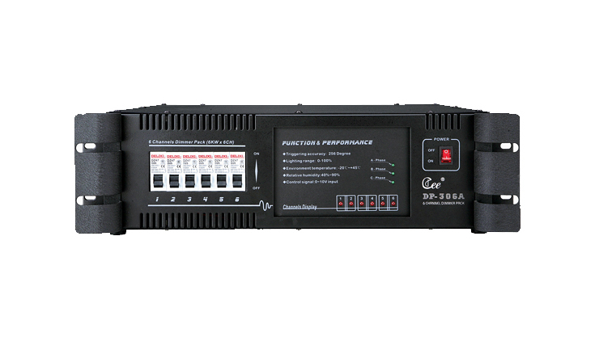
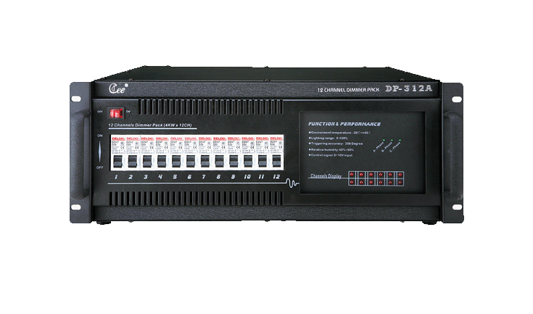

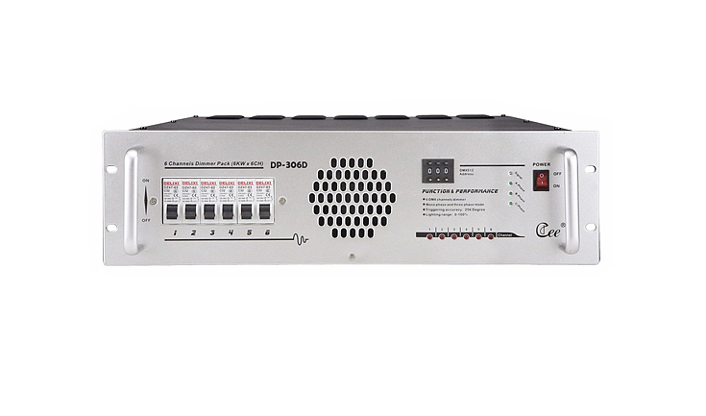

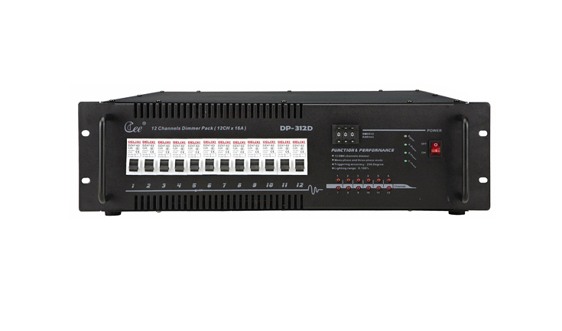

CEE DP-306A

DP-306D、DP-312D、DP-306A 、DP-312A Classic Dimmer Rack

Function and performance
●The classics silicon box design, the reasonable radiation structure, uses imports the high quality 80A controllable silicon chip, the anti-load short-circuits may reach above 200 times, the isolation voltage reaches 7500V.
●CPU numeral direct triggering, has the extremely good linearity, the uniformity and the adaptability to environment, adapts the electrical network change automatically
●The highly effective anti-jamming magnetism link, has overcome effectively to the audio equipment disturbance, guards against the thunder stroke, guards against the high-pressured string to enter the function, has safeguarded the equipment security; Has falls the DMX signal scene maintenance function, guarantees not the black field.
● Has each kind of active status demonstration and the self-checking function, divides digital, the simulation, the number/mould three kind of models, among, the number/model may accept the digital signal and the simulated signal control.
●Output circuit: 6channel (6KW/channel), 12 channel (3KW/channel)

Technical Parameter:
●Working voltage: AC220V±10% 50HZ±1 HZ
●Controlling signal:DMX-512(1990), Or DC: 0----10V
●Environmental temperature : -10℃～+35℃
●Relative humidity:20%-90%
●Working environment: Ventilating well ,and free from large amount of smoke and dust

Order Information
Model | Description | Size | Weight
DP-306D | 6ch,6kw/ch,digit lighting | 483*470*140 | 15.5kg
DP-312D | 12ch,3kw/ch,digitlighting | 483*470*185 | 17.7kg
DP-306A | 6ch,6kw/ch,analog lighting | 483*470*140 | 15.5kg
DP-312A | 12ch,3kw/ch,analog lighting | 483*470*185 | 18.8kg

