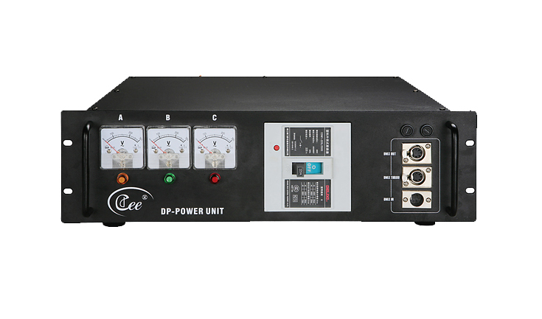

CEE DP-POWER

Function and performance
● in sets at the DMX signal processor, has guards against the short circuit, guards against exchanges has pressed, guards against the thunder stroke function.
● The DMX signal enlarges, isolates the breakdown and the enlarge transmitting range effectively.
● the convenience mains input and between various silicon box connects, has multi-channel goes nonstop to the power source.
● the three-phase voltage instruction and two step switches, conform to the power supply standard.
Order information

Model | Description | Size | Weight
DP-POWER | The multi-function power box | 483*470*140 | 10KG

