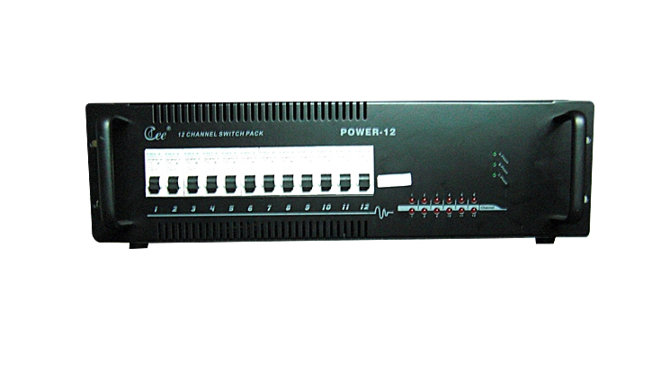

CEE POWER-6

Function and performance：

●Single-phase/three-phase power supply.
●Thermal new silicon box design, rational structure, USES the import high quality silicon controlled rectifier, isolation voltage of 7500 v.
●High efficient anti-interference magnet ring protect the AV equipment from interference .Defend to strike by lighting and high –voltage , assure the equipment safe ,Scene retain without DMX signal suddenly for preventing blackout.
●CPU numeral direct triggering, has the extremely good linearity, the uniformity and the adaptability to environment, adapts the electrical network change automatically
●Has all kinds of working state display and self-checking function, DP – 106D with 999 live.
●6 /12 channel outputs (6 kw/ch) + manual control.

Technical Parameter：
● input power supply: Three groups of 5 wire system/single-phase three-wire systems, 50Hz±1Hz, and single-phase operation voltage 220V±10%AC.
● the ambient temperature: - 10℃~+35℃, ventilates is good.
● relative humidity: 20%~90%, does not have the mist and dust.

