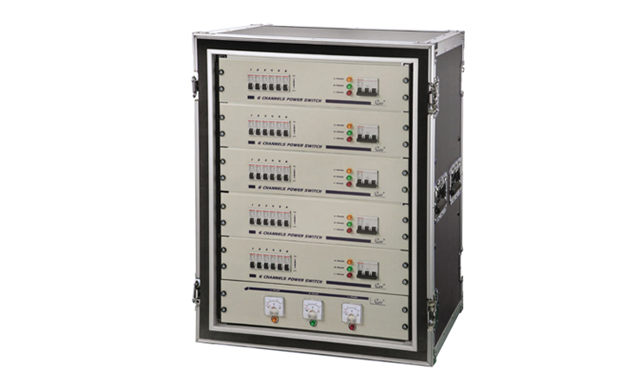

CEE POWER 18-42

18-42 channel direct-power case
Function and performance
● 18 to 42 channels for choice, between convenience power source electric appliance connection.
●With two step switches, conform to the power supply standard.
● Power instruction anterior board: voltage meters or voltage current meters for choice (customization).
●Channel switch anterior board:6-channel type or 12-channel type for choice (match with output back board, customization).
●Many kinds of output back board(3*10A,40A,three core waterproofing insert,32Athree core bakelite insert,19cores)choose time-saving.
Order information

Model | Description | Dimension(mm) | weight
POWER-18 | 18 ch | 600*520*750 | 26KG
POWER-24 | 24ch | 600*520*860 | 28KG
POWER-36 | 36 ch | 600*520*1080 | 42KG
POWER-42 | 42 ch | 600*520*1190 | 49KG

