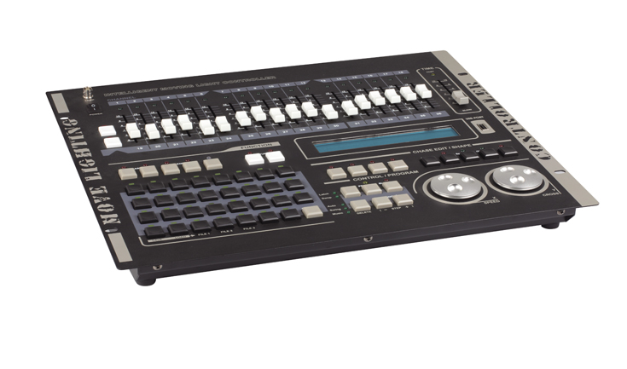

CEE CP-512

Function and performance:

DMX512/1990 standard,512 DMX control channels,photoelectric isolation signal output.
At the same time, amount of control up to 62,each has 36 control channels most,using dynamic light site settings.
16 bit X/Y control accuracy, can be set X/Y axis of the pros and cons direction.
Built-in graphics trajectory generator (SHAPE),convenient for users to graphics trajectory control of amount, picturesque, gradient, lines, eight words, waves, and other effects.Graphical parameters (such as: speed, size, development, direction) can be set independently.
62 lights program, each program step up to 100. Each TIME (TIME), the gradient (CROSS) independent setting parameters.
Optional automatic speed control, intelligent control (SWING) or manual beat music synchronization control.
Go lamp program editor, which can realize lamp program copy, paste, increase (insert), delete, and so on.
Can be run at the same time six lights program, 62 preset scenes, and lantern on 62 amount for operation at the same time.
31 MACRO environment program (MACRO), quick call different scenarios, go light, manual operation (lamp).
USB port is provided. USB-disk can record the data of controller,the file is compatible with WINDOWS XP.
With backlit LCD display operation parameters.
Maintain shutdown data.
Can work with 12 v gooseneck lamp.
Power supply: AC90-250V / 50-60Hz, high-performance green switching power supply so as to meet the requirements of power supply around the world.
Size: 482 x 440 x 105 mm

