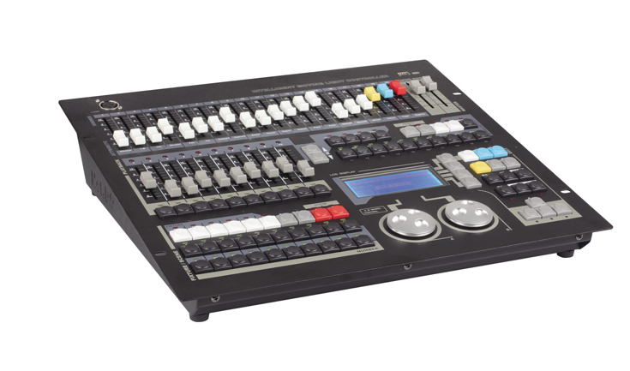

CEE CP-1024

Function and performance:

1024 DMX channels, DMX512/1990 standard, Output port with optical isolatUp to 120 intelligent Fixtures or 120 Dimmer may be connected
Up to 42 channels each Fixture. Fixture Library mode? (R20).
300 Playback program. 40 Scene can be directly used keys running, flash or latch.
SHAPE is provided to control such effects as circles, lines and dimmer effect, etc.
Chase trigger mode selectable: Auto1, Auto2, Music synchronously.
SHAPE is provided to control such effects as circles, lines and dimmer effect, etc.
USB port is provided. USB-disk can record the data of controller, Controller can be upgraded through the USB port.
LCD display with backlight.
12V accessory operate light (OPTIONAL).
Power supply: AC110-240V, 50/60Hz, 15W
Dimension: 482 x 440 x 108 mm

