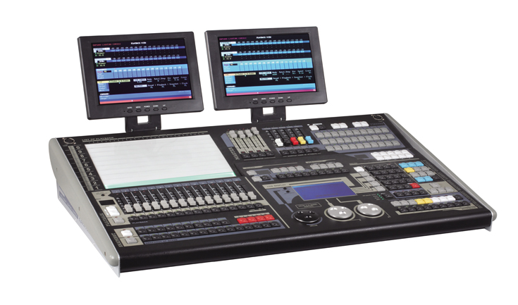

CEE CP-2048

Function and performance:

Large screen LCD display and Chinese/English menu operating mode .
2048 DMX channels most , DMX512/1990 standard, photoelectric isolation signal output.
At most, 150 computer light or 150 dimmer may be connected at the same time.
Each light has 42 control channels most,and light library mode (R20).
Largest store 600 repeat procedure is divided into 40 pages, 200 marshalling (with direct elections), 210 preset data, 100 snapshot.
135 largest generator built-in effects, convenient for the user to control the effect of amount, such as: circle, wave, the effect, the light brightness, and support the graphic overlay, deformation, and special effects.
Synchronous control program: optional internal speed, external, music synchronization or MIDI control.
With VGA display interface (display selected), intuitive man-machine interface in detail, and makes it easier to control.
USB port is provided. USB-disk can record the data of controller,the file is compatible with WINDOWS XP.
Professional work gooseneck lamp, suitable for indoor and outdoor performances.
Power supply: AC100-240V, 50-60Hz, 25W ，high-performance green switching power supply so as to meet the requirements of power supply around the world.
Dimension: 820 x 540 x 175mm

