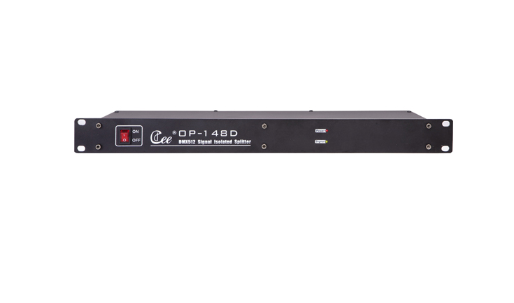

CEE OP-148D

Function and performance:
●1 input and 1 output directly.
●4/8 amplified output with optical isolated.
●Improve the loss of signal during long-range transmission.
●Solve the distribution for different direction.
●Power supply: AC100V-240V / 50-60Hz

