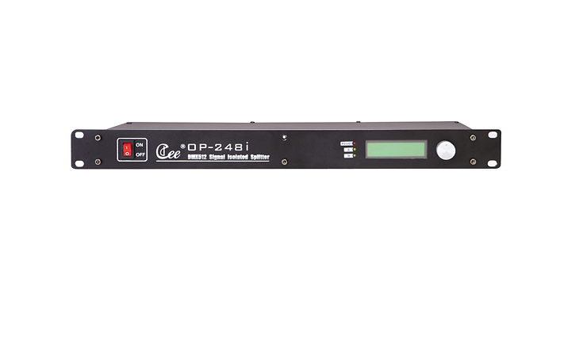

CEE OP-248i

Function & Performance:
Support standard DMX-512(1990);
2 in 8 out or two groups of 1 in 4 out independently，can resist 1000V high voltage;
Can set the input signal is A priority，B priority，the head priority ，channel superposition of four patterns；
When lost signal, it can be set up to keep output, reset output, preset scene output mode.
The power signal light， the input signal light，and LCD screen display .
You can choose three core or five core output;
Standard 1U machine cabinet installation;
Working voltage:220V～240V voltage input，50Hz;

Technical parameters:
Power supply:110v to 240v voltage input,50/60Hz.The whole machine has no-load power consumption,which is less than 5w.
DMX signal: DMX512 (1990).
Work temperature:0℃～45℃.
Work relative humidity: 20%～90%.
Storage temperature:-40℃～+55℃.
Storage relative humidity:10%～93%.

