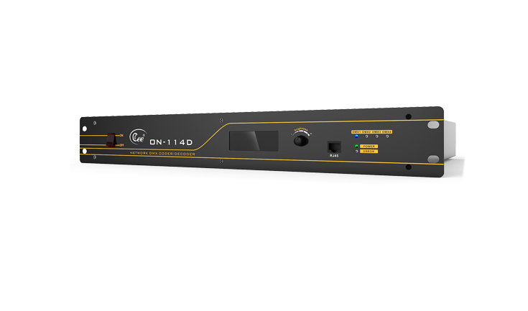

CEE ON-114D

Function and performance
● ●RJ-45 network interface (can add the fiber interface),complies with IEE802.3 ether procotols,10/100M is adaptive.
● ●The Chinese liquid crystal of LCD shows the working state. and establishment, LED points out every working state.
● ●4 DMX512 interface, can set up for(network NET≥ DMX512)or DMX512 ≥ network NET)working way.
● ●Supports the network to be set up long-rang and concentrated controlling. To after the compatible ESTA-CAN and Earthnet agreement design interface norm.
● ● DMX512 refresh rate ≤25MS.
● ●The total capacity of network≥64 groups of DMX512.

Technical parameter：
● ●Working voltage:AC220V±10%, 50HZ±1 HZ
● ●Environment temperature:-10℃～+35℃
● ●Relative humidity: 20%～90%
●Working environment: Ventilating well, and free from large amount of smoke and dust.
The order information
Module | Description | Dimension(:mm)
ON-114D | Network DMX Coder/The decoder

