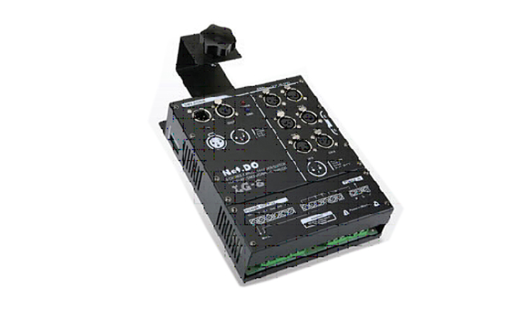

CEE LG-6BX

Function & Performance
●Convert DMX signal from controller to DC 0-10V analog signal.
●6 channels 0-10 volts analogue controlling signal output.
●Power supply：AC220V±10％，50Hz±2％,single-phase three-wire power input.
●Standard DMX512 input, address code settable.
●Using hang a wall or hanging-type installation which is easy to maintain.

