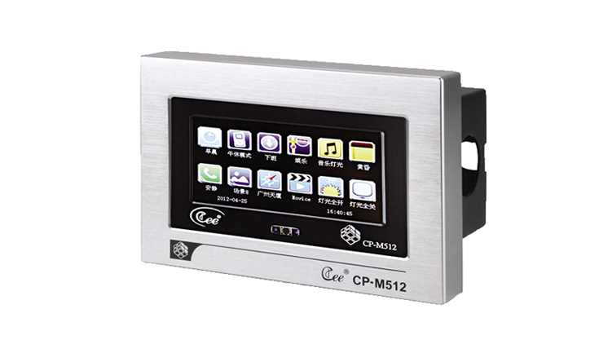

CEE CP-M512

Function and performance:
4.3 inch TFT color touch screen display
Custom icon personality, can be easily replaced
Support display in both Chinese and English
As a DMX controller, 512 light output, support the standard DMX512 (1990).
The light path of 32 region management
Save 100 scene, scene gradient time 0.1 to 60 seconds
Effect running function of two groups, each group of twenty steps, running time 0.1 to 60 seconds
100 real-time clock triggers, second level precision, real-time automatic switching scenarios
12 buttons, scene can be set/effect is triggered, the scene scene brightness adjustment
Miscro SD card saving data
Connect the computer USB interface
Support CAN – BUS bus cascading, multiple panels at the same time control lighting scenarios

Technical parameters:
Environment temperature: -10℃~+35℃,well ventilated.
Relative humidity: ２０％～９０％,no dust.

