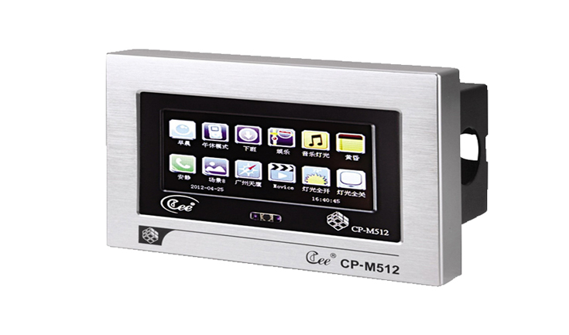

CEE CP-M512D

Function and performance:
4.3 inch TFT color touch screen display
Custom icon personality, can be easily replaced
100 real-time clock triggers, second level precision, real-time automatic switching scenarios
12 buttons, scene can be set/effect is triggered, the scene scene brightness adjustment
Miscro SD card saving data
Connect the computer USB interface
Support CAN – BUS bus cascading, multiple panels at the same time control lighting scenarios
Aluminum alloy shell, 120 general bottom box or special metal box installed.

Technical parameters:
Environment temperature: -10℃~+35℃,well ventilated.
Relative humidity: ２０％～９０％,no dust.

