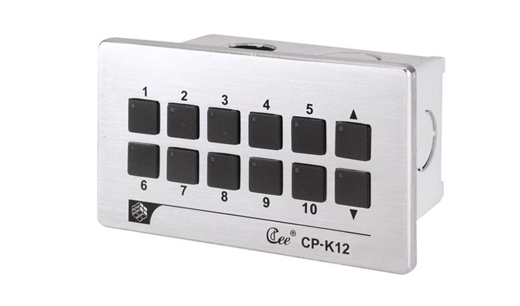

CEE CP-K12

Function and performance:
10 button set and function of rise and fall
Button lights intelligent display the light scene running state
Aluminum alloy wire drawing panel
Connect the computer USB interface
Support CAN – BUS cascading, multiple panels at the same time control lighting scenarios

Technical parameters:
Environment temperature: -10℃~+35℃,well ventilated.
Relative humidity: ２０％～９０％,no dust.

