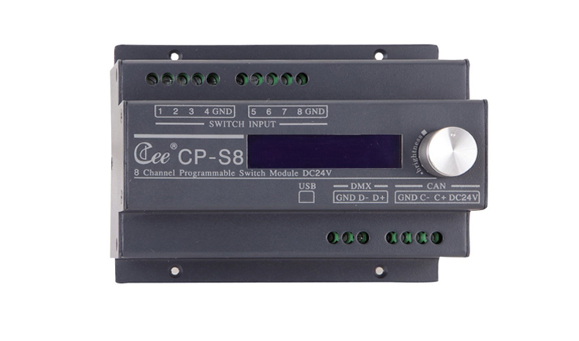

CEE CP-S8

Function and performance:
Can be an external CP - K12 or a third party button switch panel.
8-way programmable dry contact input, can be an external human body infrared sensor, etc
Can be set for each contact work time
As a DMX controller, 256 light output, support the standard DMX512 (1990).
LCD liquid crystal display
The light path of 32 region management
Save 200 scene, scene gradient time 0.1 to 60 seconds
Effect running function of four groups, each group of twenty steps, running time 0.1 to 60 seconds.
100 real-time clock triggers, second level precision, real-time automatic switching scenarios
Connect the computer USB interface
Support CAN – BUS bus cascading, multiple panels at the same time control lighting scenarios
A standard 35 mm guide or the number of the fixed installation

Technical parameters:
Environment temperature: -10℃~+35℃,well ventilated.
Relative humidity: ２０％～９０％,no dust.

