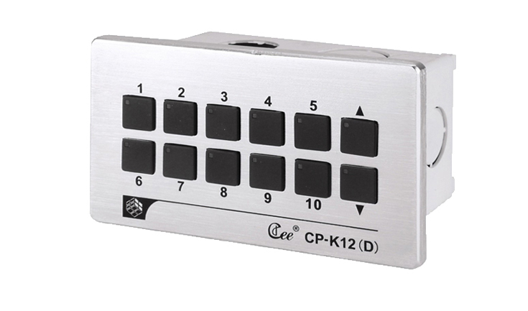

CEE CP-K12D

Function and performance:
10 button set and function of rise and fall
Button lights intelligent display the light scene running state
As a DMX controller, 128 light output, support the standard DMX512 (1990).
The light path of 32 region management
Save 100 scene, scene gradient time 0.1 to 60 seconds
Effect running function of two groups, each group of twenty steps, running time 0.1 to 60 seconds
Aluminum alloy wire drawing panel
Connect the computer USB interface
Support CAN – BUS bus cascading, multiple panels at the same time control lighting scenarios

Technical parameters:
Environment temperature: -10℃~+35℃,well ventilated.
Relative humidity: ２０％～９０％,no dust.

