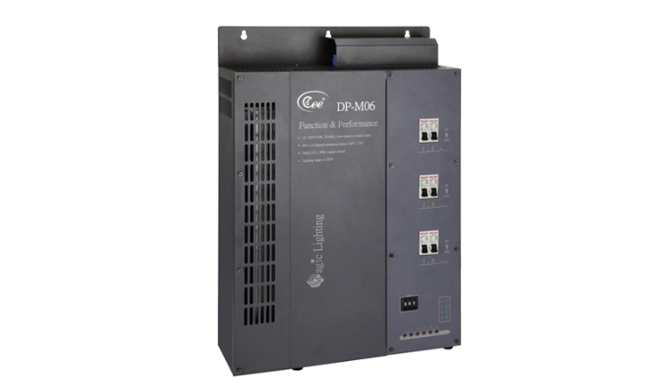

CEE DP-M06

Function and performance:
Six channels 0-100% linear dimming,every channel's maximum current is 20A(4KW,220V)
Power supply:AC220v±10%，50Hz±2%，single-phase to three-phase power input five line
Standard DMX512 signal control (1990)
Each channel has a separate insurance tube with over-current protection function.
Using convection cooling heat,overtemperature protection system, to ensure product sustainable operation.
Select imported high quality silicon controlled rectifier and the maximum isolation voltage is 7500 v.
Using high-performance choke coil suppress harmonic componenteffectively reduces electromagnetic noise.
High precision through zero detection technology,each channel output consistency is good.
Possible being set up manually through the output which can realize emergency output when signal is lost.
Using wall-hung type installation,easy to maintain.
The optional 4.3 inch touch panel,standard DMX512 controlling signal output.

