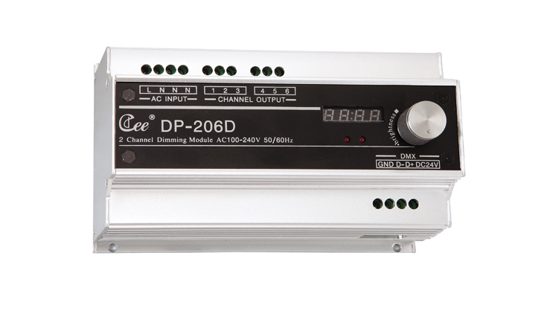

CEE DP-206D

Function and performance:
Two channels 0-100% linear dimming,
2 channels x 6.5 A, the maximum total current is 13 A.
The adaptive grid type detection,110V-220V，50Hz-60Hz±2%
Standard DMX512(1990) signal control
DMX address of each circuit can be soft adaptor
Temperature display function
All aluminum alloy shell heat dissipation, when internal temperature higher than 70 ℃,it will start the warning and limit the output of 50%.
Selects imported high quality silicon controlled rectifier and the maximum isolation voltage is 7500 v.
Using high-performance choke coil suppress harmonic componenteffectively reduces electromagnetic noise.
High precision through zero detection technology,each channel output consistency is good.
Possible being set up manually through the output which can keep output when signal is lost and avoid black out.
A standard 35 mm guide or the number of the fixed installation.

Technical parameters:
Power supply:AC220～240V,50/60Hz
The whole machine with no-load power consumption is less than 1w.
Output circuit:2 channels
Each channel's maximum output current:6.5A
The 2 channels maximum total output current:13A
Environment teperature:0℃~45℃
Working relative humidity:20%~90%
Storage temperature:-40℃~+55℃
Storage relative humidity:10%~93%

