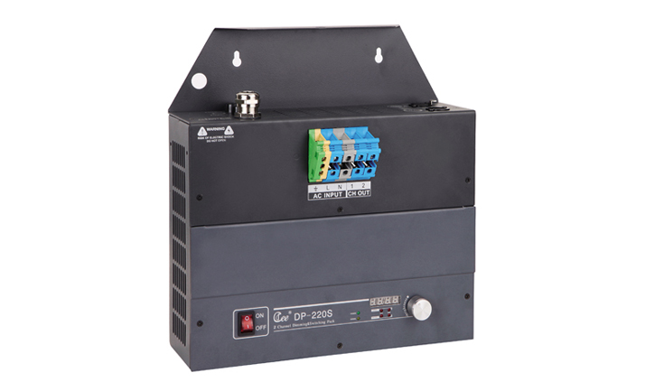

CEE DP-220S

Function and performance:
2 channels switch control,2 channels * 20A
Power supply:AC220V±10%，50Hz±2%，single-phase three-wire power input.
Zero voltage switching action,effectively restrain relay contact spark.
Standard DMX512 signal control (1990)
High precision through zero detection technology,each channel output consistency is good.
Using wall-hung type or hanging-type installation，easy to maintain.

Bus power consumption:
Dynamic current:40mA/DC24V
Quiescent current:15 mA/DC24V
Switch circuit :12 channels
Each switch circuit maximum current：16A
Relay contact electrical life:＞ 60000 times（resistance load）

