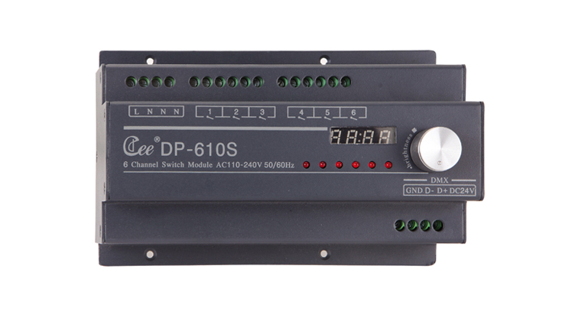

CEE DP-610S

Function and performance:
6 channels switch control,6 channels * 10A
The adaptive grid type detection,110V-220V，50Hz-60Hz±2%
Zero voltage switching action,effectively restrain relay contact spark.
Standard DMX512 signal control (1990)
High precision through zero detection technology,each channel output consistency is good.
Possible being set up manually through the output which can keep output when signal is lost and avoid black out.
A standard 35 mm guide or the number of the fixed installation.

Technical parameters:
Power input:AC220V±10% 50Hz±2%
The whole machine with no-load power consumption is less than 1w.
Output circuit: 6 channels
Each channel's output current:10A
Rising time:more than 200靤
Working temperature:0℃~45℃
Working relative humidity:20%~90%
Storage temperature:-40℃~+55℃
Storage ralative humidity:10%~93%
Bus power consumption:
Dynamic current:40mA/DC24V
Quiescent current:15 mA/DC24V
Switch circuit :12 channels
Each switch circuit maximum current：16A
Relay contact electrical life:＞ 60000 times（resistance load）

