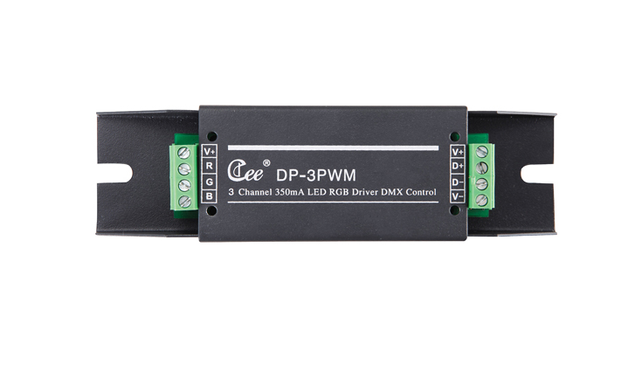

CEE DP-3PWM

Function and performance:
Three channels adjustable light LED constant current drive output,single-channel maximum current is 350 mA / 700 mA.
24 v ～ 36 v voltage input.
Standard DMX512 signal control (1990).
More than 1024 high-precision dimmer.
More than 2 KHz high refresh rate.

