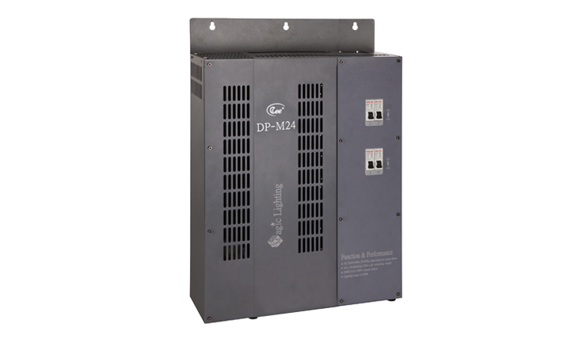

CEE DP-M24

Function and performance:
Optional installation the following four to eight items that move light/switch module.
Independent air switch insurance 4 road.
The optional 4.3 -inch touch panel,standard DMX512 signal control (1990).

Technical parameters:
Dimming Range:0-100%
Continuous working period:24 hours
Working temperature：0℃-40℃
Relative humidity：10%-90%

