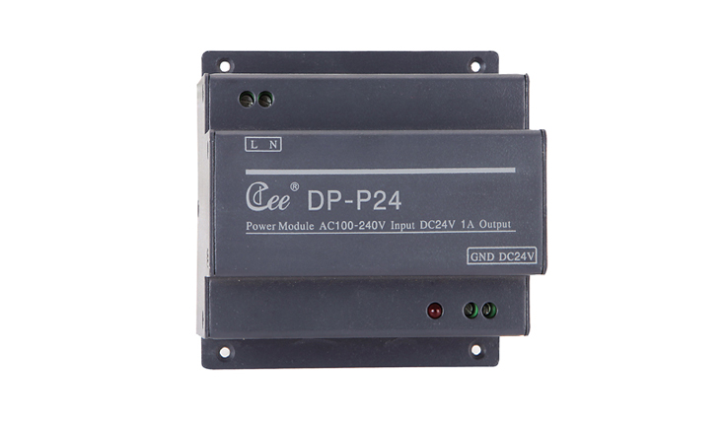

CEE DP-P24

Function and performance:
Bus power supply module；
International general full range of AC input，88V～264V.
24VDC，1Aoutput.
Standard DMX512 signal control (1990).

