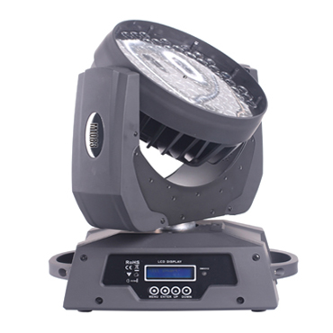

CEE LP-M1083 LED Focusing Moving Head Light

Technical parameter：

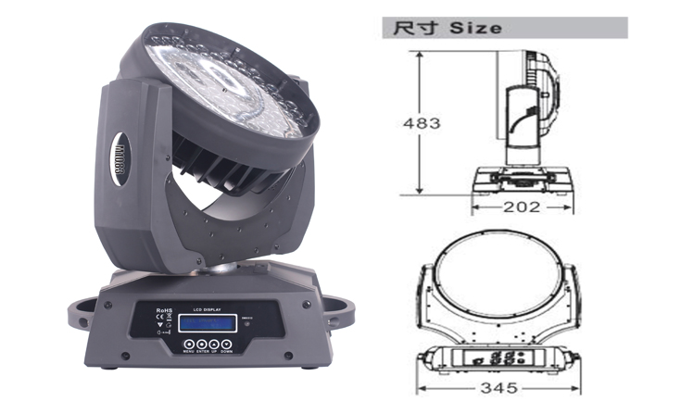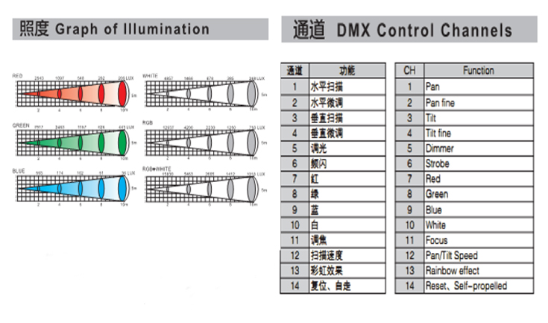
Light Source： 108 x 3W 4 in 1 RGBW
Color： RGBW continuously variable color mixing
Beam Angle： 15°－45°
Power Supply： AC 90V-240V, 50 / 60Hz
Power Consumption： 350W
Control： DMX-512, master/slave mode, self-propelled and sound activated
Channel： 14CH standard mode
Movement Range： Pan 540°, 16 Bit resolution, automatic position correction
Tilt 270°, 16Bit resolution, automatic position correction
Dimming Accuracy： 8192 class
Strobe： 1-25 flash per second
Environment： -20℃～40℃, well ventilated
Protection Class： IP20
Size： 345 x 202 x 483mm
Weight： 9kg

