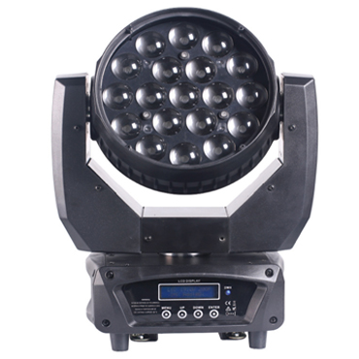

CEE LP-M1912 LED Focusing Moving Head Light

Technical parameter：

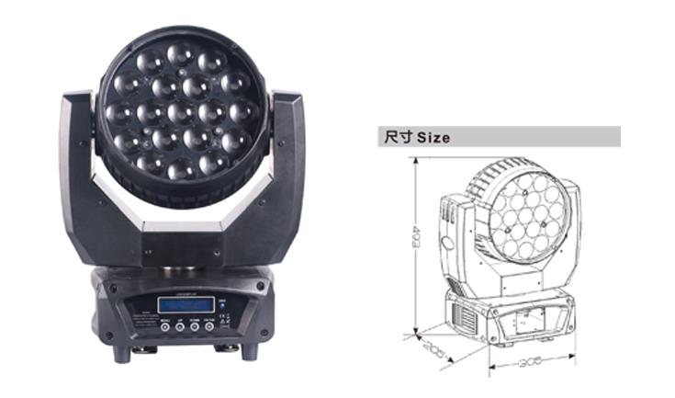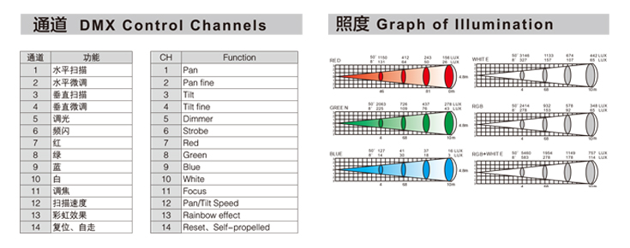
Light Source： 19 x 12W 4 in 1 RGBW
Color： RGBW continuously variable color mixing
Beam Angle： 8°－50°
Power Supply： AC 90V-240V, 50 / 60Hz
Power Consumption： 250W
Control： DMX-512, master/slave mode, self-propelled and sound activated
Channel： 14CH standard mode
Movement Range： Pan 540°, 16 Bit resolution, automatic position correction
Tilt 270°, 16Bit resolution, automatic position correction
Dimming Accuracy： 8192 class
Strobe： 1-25 flash per second
Environment： -20℃～40℃, well ventilated
Protection Class： IP20
Size： 305 x 205 x 493mm
Weight： 7.5kg

