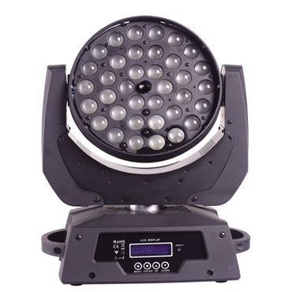

CEE LP-M3610 LED Focusing Moving Head Light

Technical parameter：

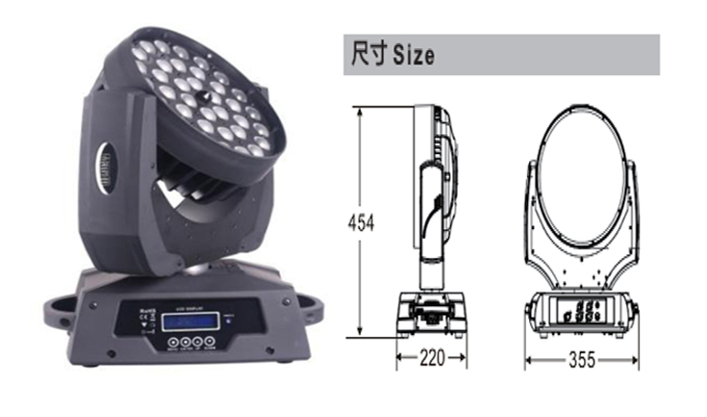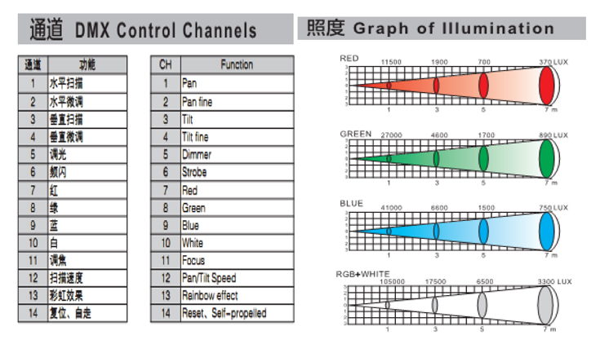
Light Source： 36 x 10W 4 in 1 RGBW
Color： RGBW continuously variable color mixing
Beam Angle： 12°－55°
Power Supply： AC 90V-240V, 50 / 60Hz
Power Consumption： 400W
Control： DMX-512, master/slave mode, self-propelled and sound activated
Channel： 14CH standard mode
Movement Range： Pan 540°, 16 Bit resolution, automatic position correction
Tilt 270°, 16Bit resolution, automatic position correction
Dimming Accuracy： 8192 class
Strobe： 1-25 flash per second
Environment： -20℃～40℃, well ventilated
Protection Class： IP20
Size： 355 x 220 x 454mm
Weight： 9kg

