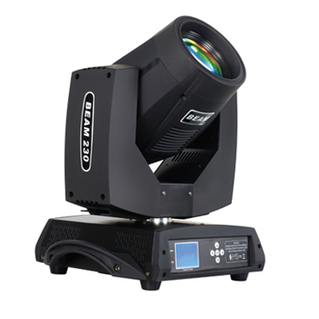
CEE LP-230B Moving Head Beam Light

Technical parameter：

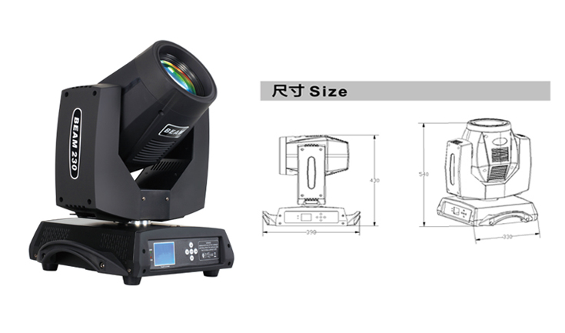
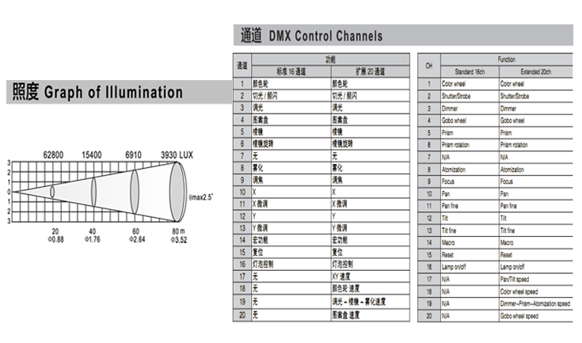
Lamp： YODN MSD 230 R7 (OSRAM or PHILIPS selectable）
Lamp Life： 2000 H
Lumen： 10200 lm
Color Temperature： 8000K±300K
Beam Angle： Parallel Beam Angle 0－3.9°
Power Supply： AC 100V-240V，50/60Hz
Power Consumption： 280W
Control Signal： DMX-512 (1990)
Channel：16CH standard mode / 20ch extended mode
Movement Range： Pan 540°, 16Bit resolution, automatic position correction
Tilt 270°, 16Bit resolution, automatic position correction
Linear Dimmer： Mechanical linear dimmer 0－100%
Color Wheel： 1 fixed color wheel（14 color filters + white）, linear color conversion, semi-color effect, rainbow effect in both directions
Gobo Wheel： 17 fixed gobos + white, with gobo shake function at variable speed / rotating effect in both directions
Prism： Independent 16-facet prism, prism locating function and rotating in both directions at
variable speed
Focus： Incredibly flexible linear focus
Strobe： variable strobe 1-15 flashes per second, selectable random or pulse strobe
Atomization： 0-100% linear atomization
Environment： -20℃～40℃, well ventilated
Protection Class： IP20
Size： 398 x 330 x 540mm
Weight： 17.3Kg

