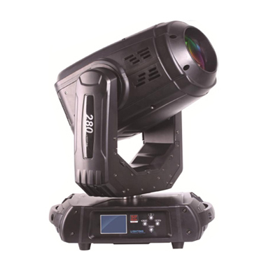
CEE LP-280(3 in 1)Moving Head Light

Technical parameter：

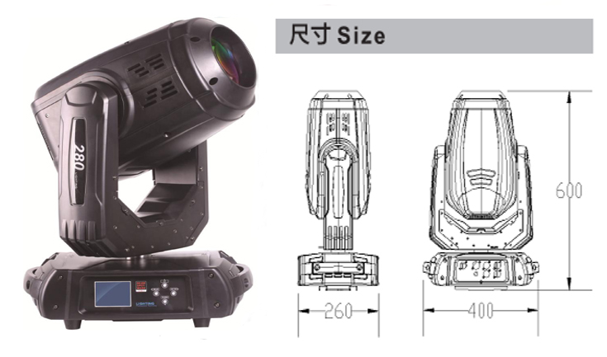
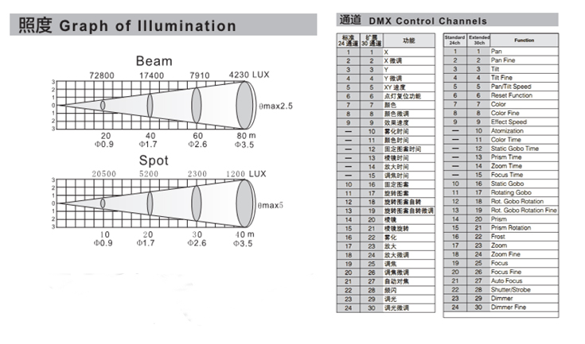
Lamp： YODN MSD 280 R10 (OSRAM or PHILIPS selectable）
Lamp Life： 1500 H
Color Temperature： 8000K
Beam Angle： Beam mode 2.5－10°，Spot mode 5－20°
Power Supply： AC 100V-240V，50/60Hz
Power Consumption： 360W
Control Signal： DMX-512 (1990)
Channel：24CH standard mode / 30ch extended mode
Movement Range： Pan 540°, 16Bit resolution, automatic position correction
Tilt 270°, 16Bit resolution, automatic position correction
Linear Dimmer： Mechanical linear dimmer 0－100%
Color Wheel： 1 fixed color wheel（13 color filters + white）, linear color conversion, semi-color effect, rainbow effect in both directions
Gobo Wheel：14 fixed gobos + white, with gobo shake function at variable speed/rotating effect in both directions
9 rotating gobos + White, with gobo shake function at variable speed / rotating effect in both directions
Prism：8-facet circular prism rotating in both directions at different speeds
6-facet linear prism rotating in both directions at different speeds
Focus： Incredibly flexible linear focus
Strobe： variable strobe 1-15 flashes per second, selectable random or pulse strobe
Atomization： 0-100% linear atomization
Environment： -10℃～40℃, well ventilated
Protection Class： IP20
Size： 400 x 260 x 600mm
Weight： 15Kg

