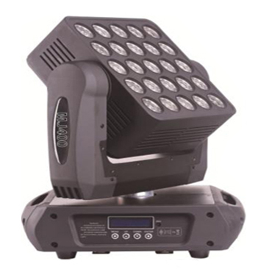

CEE LP-MJ400 LED Moving Head Matrix Light

Technical parameter：

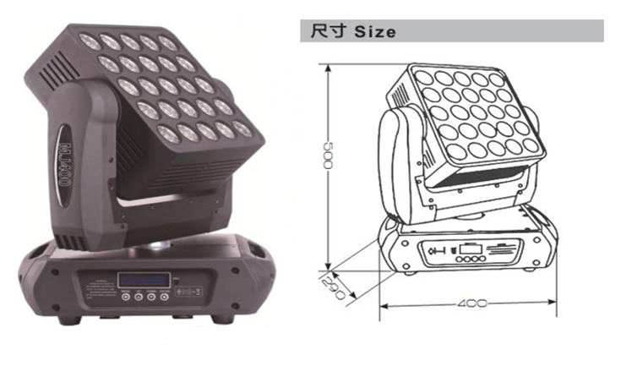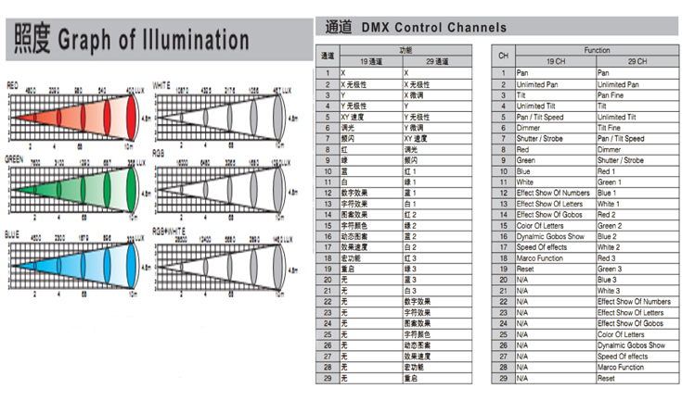
Light Source： 25 x 12W 4 in 1 RGBW
Beam Angle：7°
Power Supply： AC 90V-240V，50 / 60Hz
Power Consumption： 400W
Control Signal： DMX-512 (1990)
Channel：19 / 29 channel mode
Movement Range： Unlimited Pan, 16Bit resolution, automatic position correction
Unlimited Tilt, 16Bit resolution, automatic position correction
Dimmer：0-100％ linear dimming
Strobe：1-25 flash per second
Environment： -20℃～40℃, well ventilated
Protection Class： IP20
Size： 400 x 290x 500mm
Weight： 14.4kg

